**Computer Networks**

**Network design project**



Student: Nguyen Thanh Tuan (NGU0120)

Bui Tuan Vu (BUI0016)

Teacher: Ing. Pavel Moravec, Ph.D.

# **Assignment**

Design a configure a corporate network connected to the Internet. Verify, test and submit your solution in parts either via the Distributed Virtual Networking Laboratory (Virtlab) or electronically to an E-mail address given to you by your lab assistant backing up the functionality by supplying requested information.

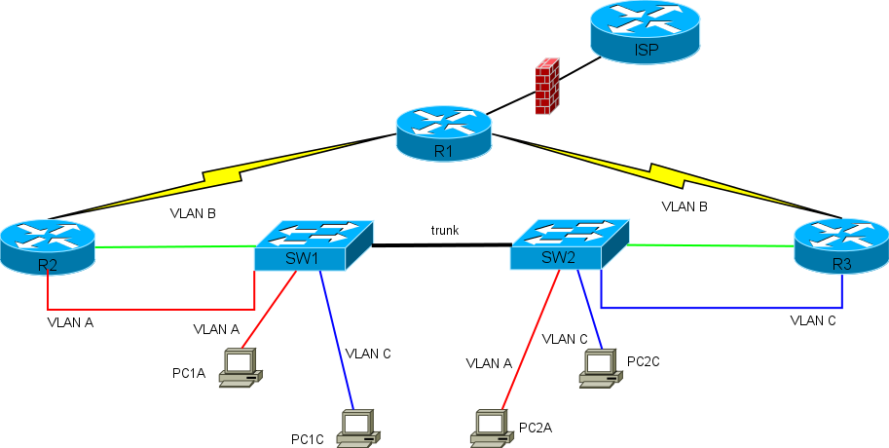Parametrization: Moravec-EN-VN_3  
------------------------------------  
Domain: ahsoo  
Topology ID: C  
VLAN numbers: VLAN A=68, VLAN B=92, VLAN C=116  
Stations on segments: VLAN A=52, VLAN C=170  
Public prefix: 81.145.192.0/18  
Private prefix: 10.249.244.128/25  
IPv6 prefix: 2002:57c7:2dac::/48  
Segments with special meanings: NAT: VLAN A, DNS: VLAN C (PC2C), DHCP: VLAN C, T: VLAN C, N: VLAN C  
NAT pool: 35  
Routing protocol: RIP

# **Network Description**

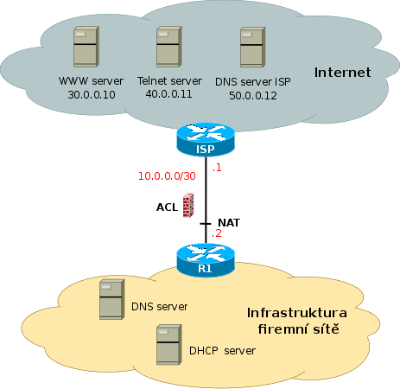

* The corporate network is connected to the ISP router by customer router R1. The line between routers ISP and R1 uses private address range that is not propagated into the Internet. A static router to the public address range of the corporate network is configured at ISP router and is propagated to the Internet.
* The corporate network boundary router (R1) filters the traffic between the corporate network and the Internet using ACL (Access Control Lists). Hosts residing on the Internet are represented by servers with addresses 30.0.0.10, 40.0.0.11 and 50.0.0.12.
* Various Cisco routers, Cisco Catalyst 2900-series switches and hubs are used in the corporate network infrastructure. The structure of the corporate network corresponds to one of the Topologies depicted in the Appendix (it will be assigned by a teacher to every single group of students, together with the other design parameters). The ISP router and servers in the Internet are pre-configured and inaccessible to the students.

# L3 Topology

**IPv4:**

|  |  |  |
| --- | --- | --- |
| **Name** | **Calculate** | **Netmask** |
| VLAN A | 52 + 1 +2 = 55 <= 26 | 32 – 6 = 26 (/26) |
| VLAN B | 0 + 2 + 2 = 4 <= 22 | 32 – 2 = 30 (/30) |
| VLAN C | 170 + 1 + 2 = 173 <= 28 | 32 – 8 = 24 (/24) |
| VLAN A (NAT POOL) | 35 + 1 +2 = 38 <= 26 | 32 – 6 = 26 (/26) |
| R1 – R2 | 0 + 2 + 2 = 4 <= 22 | 32 – 2 = 30 (/30) |
| R1 – R3 | 0 + 2 + 2 = 4 <= 22 | 32 – 2 = 30 (/30) |
| R1 - ISP | 0 + 2 + 2 = 4 <= 22 | 32 – 2 = 30 (/30) |

Private Address:

|  |  |  |  |
| --- | --- | --- | --- |
| **Name** | **Subnet** | **Usable Addresses** | **Broadcast** |
| VLAN A | 10.249.244.128/26 | 10.249.244.129 - 10.249.244.190 | 10.249.244.191 |

Public Address:

|  |  |  |  |
| --- | --- | --- | --- |
| **Name** | **Subnet** | **Usable Addresses** | **Broadcast** |
| VLAN C | 81.145.192.0/24 | 81.145.192.1 – 81.145.192.254 | 81.145.192.255 |
| NAT POOL | 81.145.193.0/26 | 81.145.193.1 – 81.145.193.62 | 81.145.193.63 |
| VLAN B | 81.145.193.64/30 | 81.145.193.65 – 81.145.193.66 | 81.145.193.67 |
| R1 – R2 | 81.145.193.68/30 | 81.145.193.69 – 81.145.193.70 | 81.145.193.71 |
| R1 – R3 | 81.145.193.72/30 | 81.145.193.73 – 81.145.193.74 | 81.145.193.75 |
| R1 - ISP | 10.0.0.0/30 | 10.0.0.1 – 10.0.0.2 | 10.0.0.3 |

DNS: 81.145.192.254

**IPv6:**

IPv6 prefix: 2002:57c7:2dac::/48

|  |  |  |  |  |
| --- | --- | --- | --- | --- |
| **Name** | **Address** | **The First Use. Address** | | **Last Used Address** |
| VLAN C | 2002:57c7:2dac:0000::/64 | 2002:57c7:2dac:0000::1 | 2002:57c7:2dac:0000::ffff:ffff:ffff:ffff | |
| VLAN A | 2002:57c7:2dac:0001::/64 | 2002:57c7:2dac:0001::1 | 2002:57c7:2dac:0001::ffff:ffff:ffff:ffff | |
| VLAN B | 2002:57c7:2dac:0002::/64 | 2002:57c7:2dac:0002::1 | 2002:57c7:2dac:0002::ffff:ffff:ffff:ffff | |
| R1 – R2 | 2002:57c7:2dac:0003::/64 | 2002:57c7:2dac:0003::1 | 2002:57c7:2dac:0003::ffff:ffff:ffff:ffff | |
| R1 – R3 | 2002:57c7:2dac:0004::/64 | 2002:57c7:2dac:0004::1 | 2002:57c7:2dac:0004::ffff:ffff:ffff:ffff | |
| R1 – ISP | 2002:57c7:2dac:0005::/64 | 2002:57c7:2dac:0005::1 | 2002:57c7:2dac:0005::ffff:ffff:ffff:ffff | |

# Address Topology

